# Education Management Installation Guide

[**https://github.com/sukrit-adhikari-1/education-management-system**](https://github.com/sukrit-adhikari-1/education-management-system)

1. Pull code to xampp/htdocs/demo folder.
2. You should also have MySQL running.
3. Create a database ‘demo’ in your MySQL.
4. The username of MySQL will be ‘root’ and password will be empty (no password i.e default settings).
5. You should have PHP version at least 5.5.X but NOT PHP 7.
6. You should have command line PHP. You need to add c:\xampp\php in your path variable. Google it if you don’t know how. You can verify command line php by running following command.



1. Download https://getcomposer.org/Composer-Setup.exe composer and install.
2. Point your php.exe in Composer Installation.

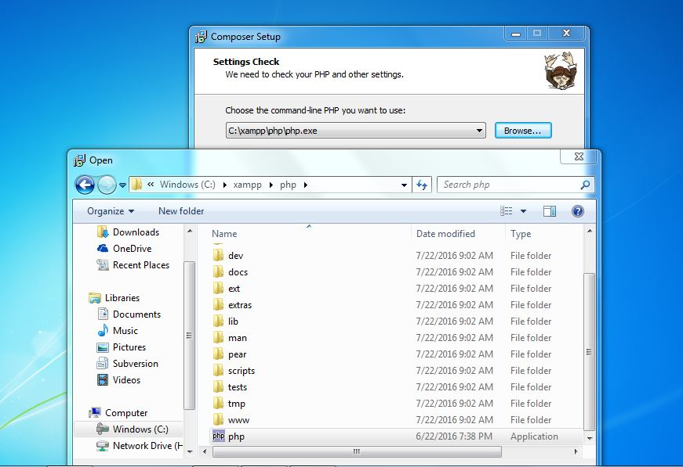

1. Skip proxy settings.
2. Verify Composer installation.

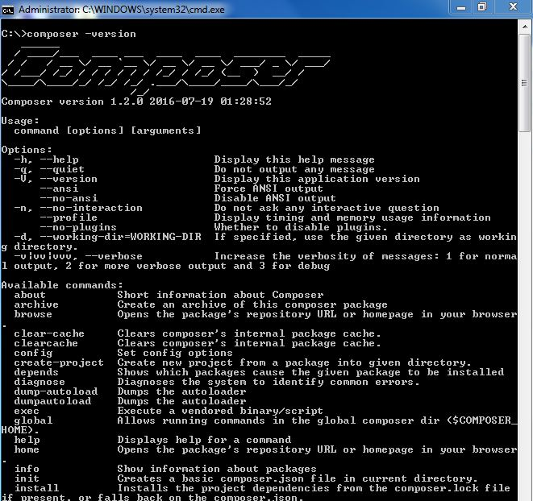

1. Verify you have artisan working. Go to your folder (xampp/htdocs/demo) and run “PHP artisan list” command.

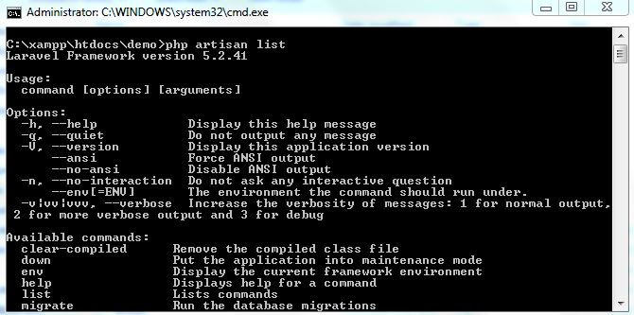

1. **For installation** Run “composer update” and then “php artisan product-install” from command line in your ‘xampp/htdocs/demo’.

**Or** goto ‘cts-dev-scripts/installation’ and run product-install.bat .

1. If you encounter any class not found or facade not found error go to

‘cts-dev-scripts/fix’ and run optimize.bat

1. You should see tables and default rows in your MySQL>demo database
2. Go to <http://localhost/demo> and you should see login page

Email Address: [teacher@cts.com](mailto:teacher@cts.com)

Password: abc

